DEPLOY THE PYTHON BASED APPLICATION

SIGN into the aws console and create an ec2 instance with the ubuntu server and give the custamized vpc and security group are

SSH-22

HTTP-443

HTTPS-8080

TCP-7070,8000

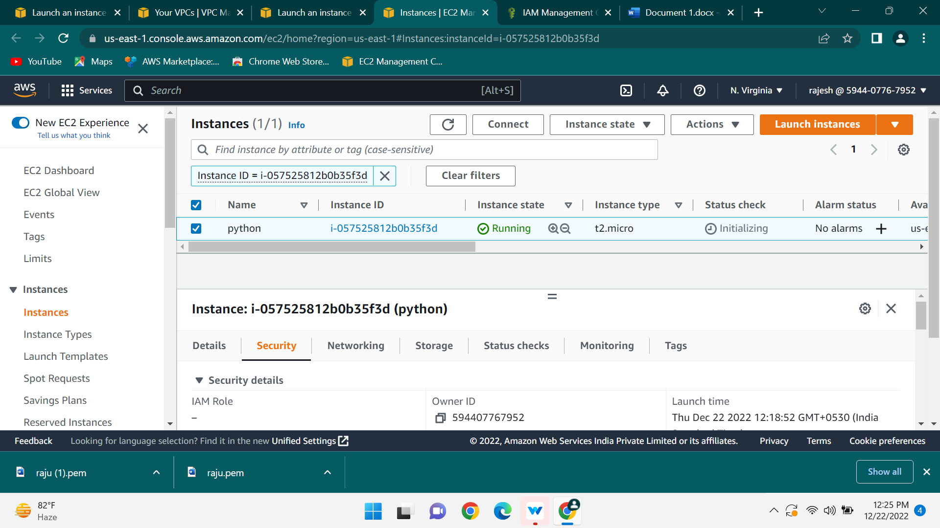

Connect the ec2 instance with the terminal and update the system with the help of the command

----> sudo apt update

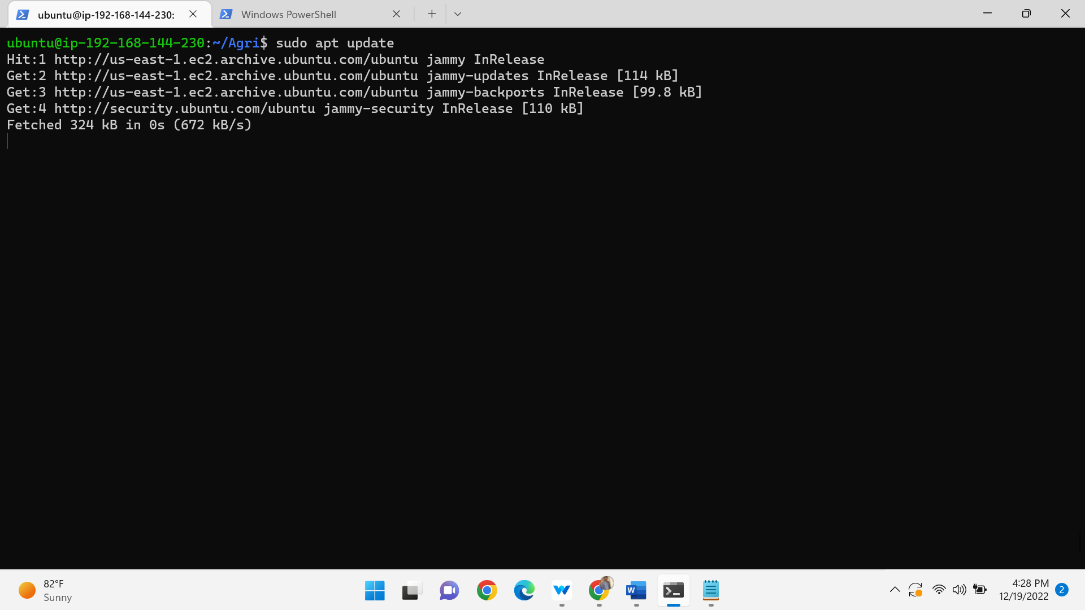

After upgrade the packages in the ubuntu machine with the help of the command

Sudo apt-get full-upgrade –y

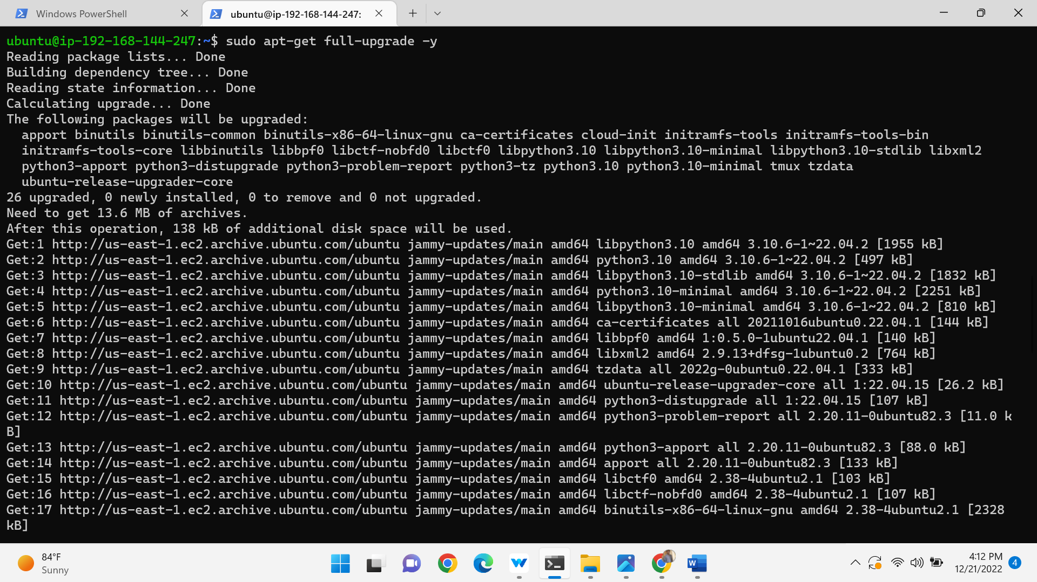

And then install the python in the ubuntu machine

Pip3 is the official package manager and pip command for python3 .it enables the installation and management of third party software packages with features and functionality not found in the python standard library.

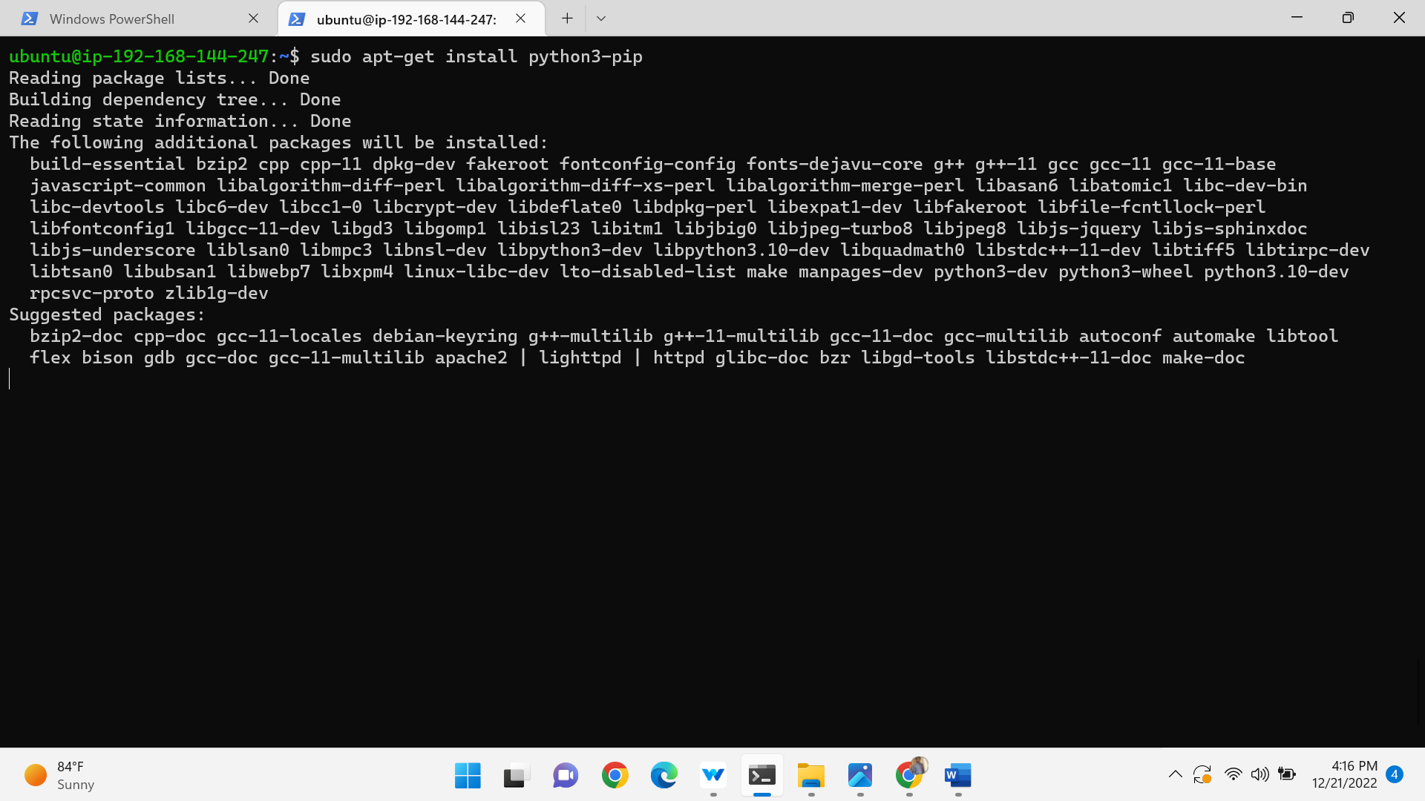

And clone the code from the repository by using

Git clone <https://github.com/TGourisankar/flight-prediction.git>

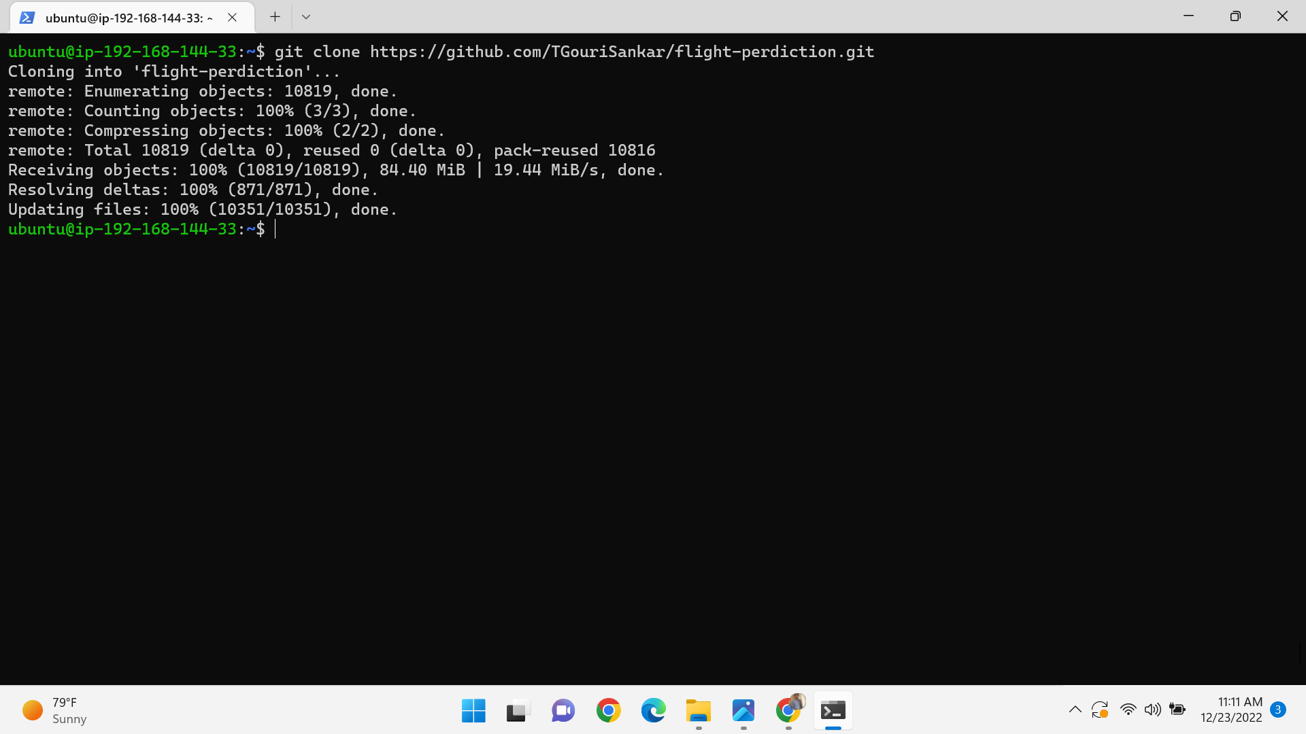

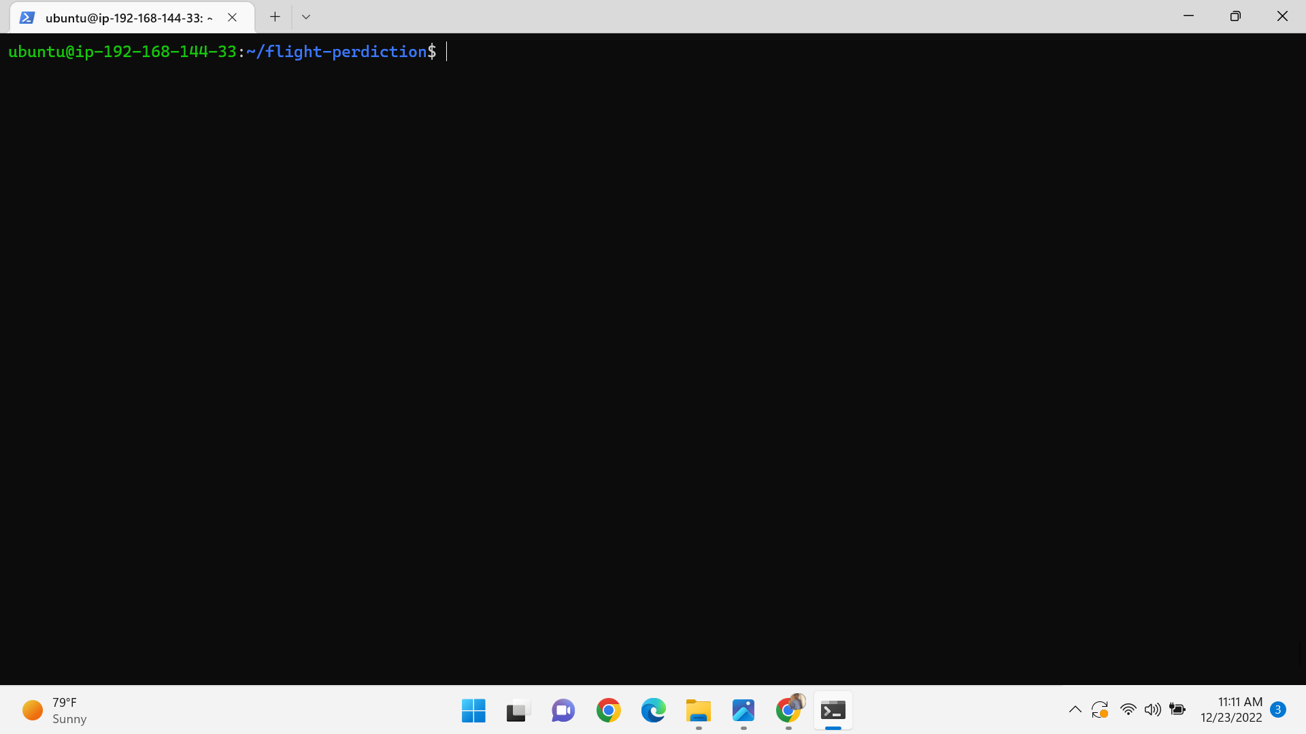

And go to the directory install the required packages and run the flask server

--> pip3 install –r requirements.txt

--> python3 app.py

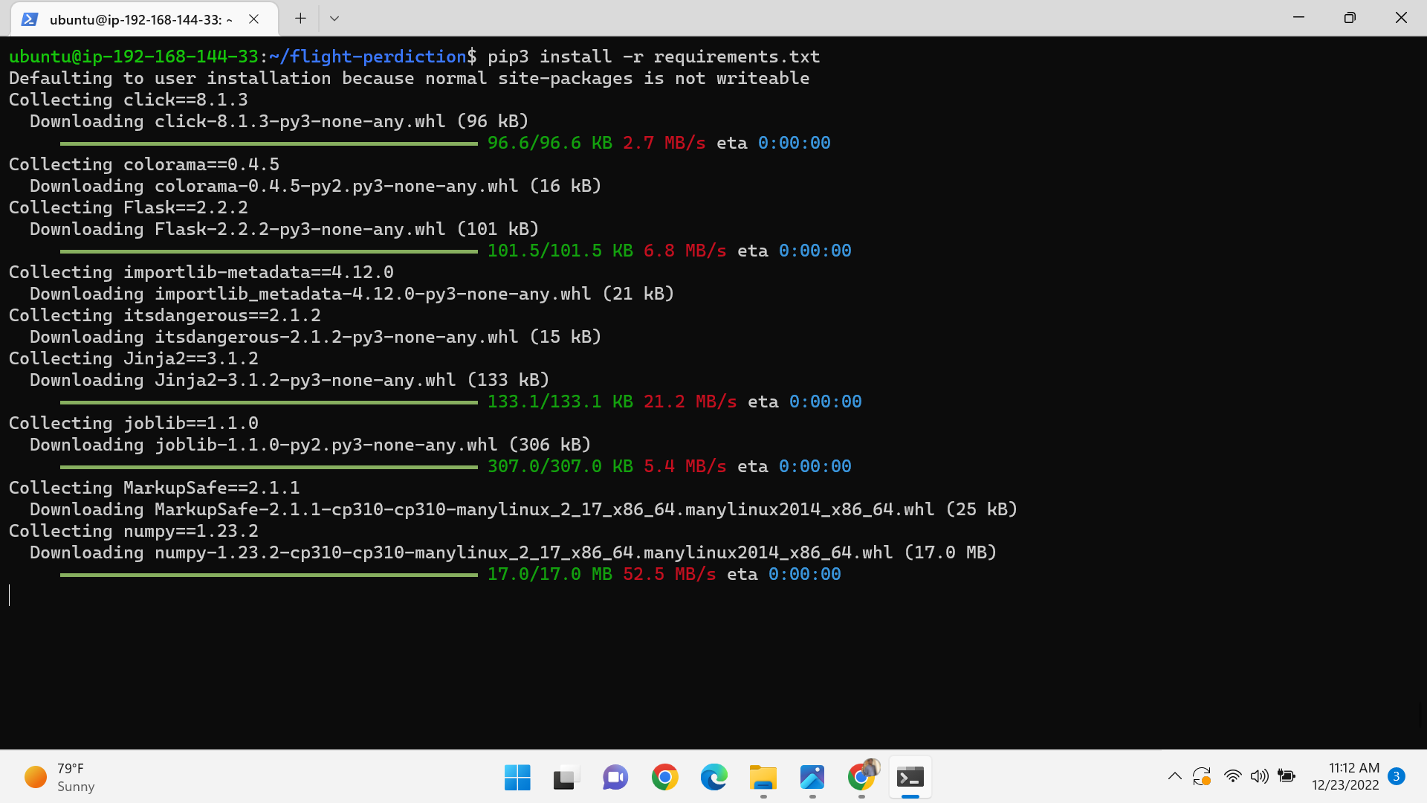

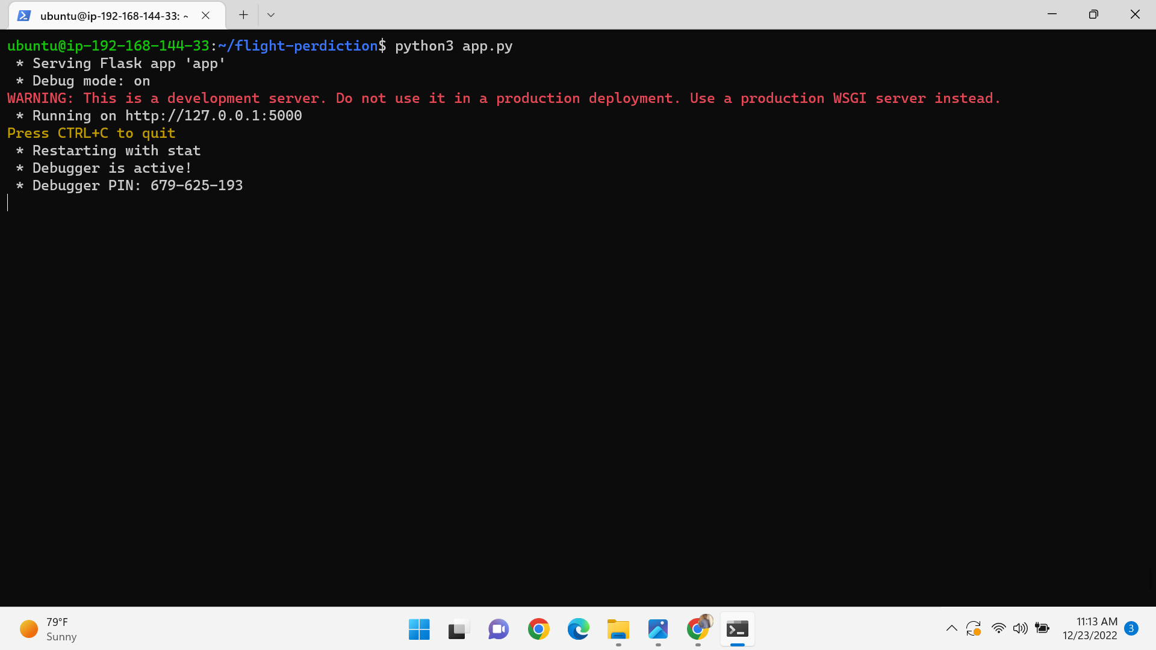

Here, after running python3 app.py it will generate local host ip address we can’t access web app with that ip adress then here we want to edit the file app.py with some details.

Sudo vi app.py

Go to the very bottom of the file and paste the following text and save the file

App.run(host=’0.0.0.0’, port=8080, debug=True)

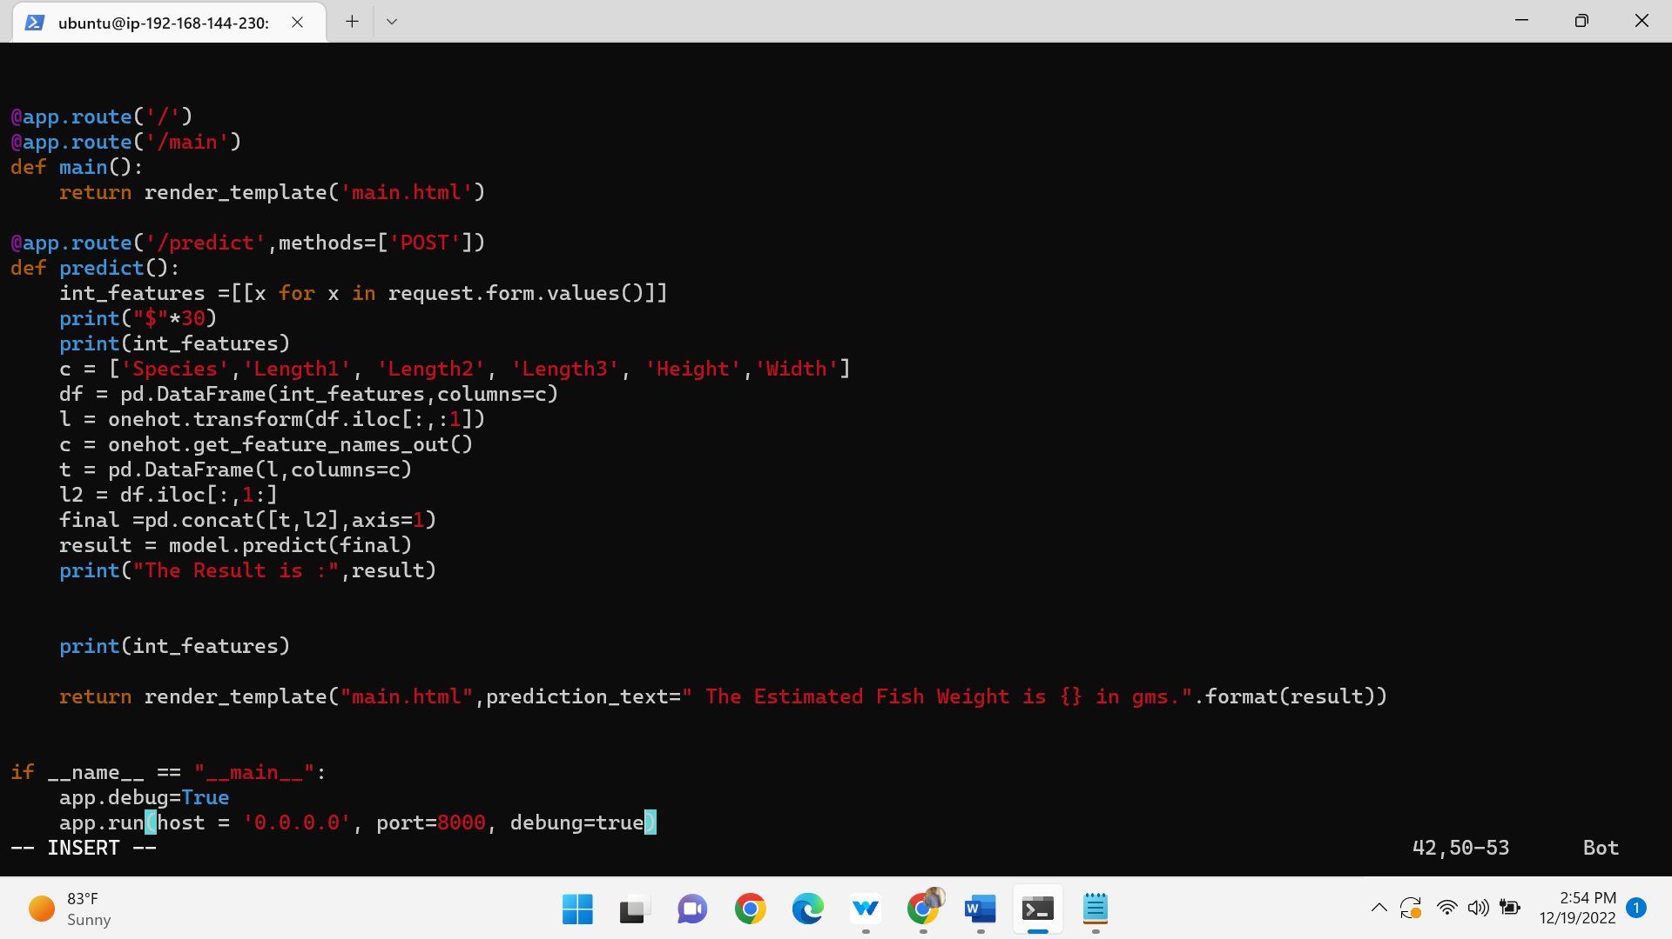

Now again run the flask server by using the below command

Python3 app.py

Copy the public ip adress and paste it on terminal with required port number

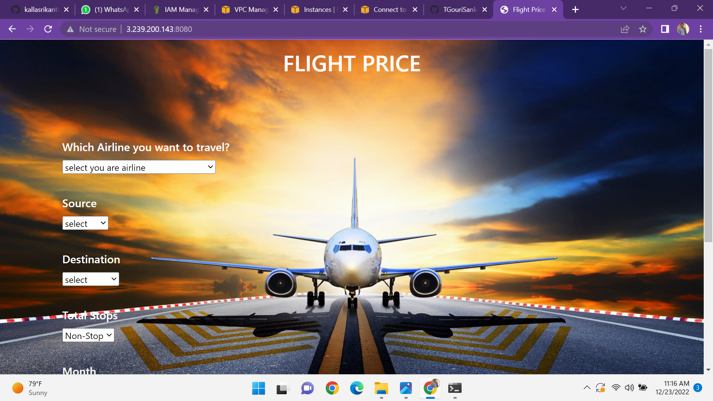

And again clone the car-perdiction repository

Go to that directory install the requirements .txt

Run the flask server

Edit the sudo vi app.py

And again run python3 app.py

Copy the public ip adress and paste it on the browser

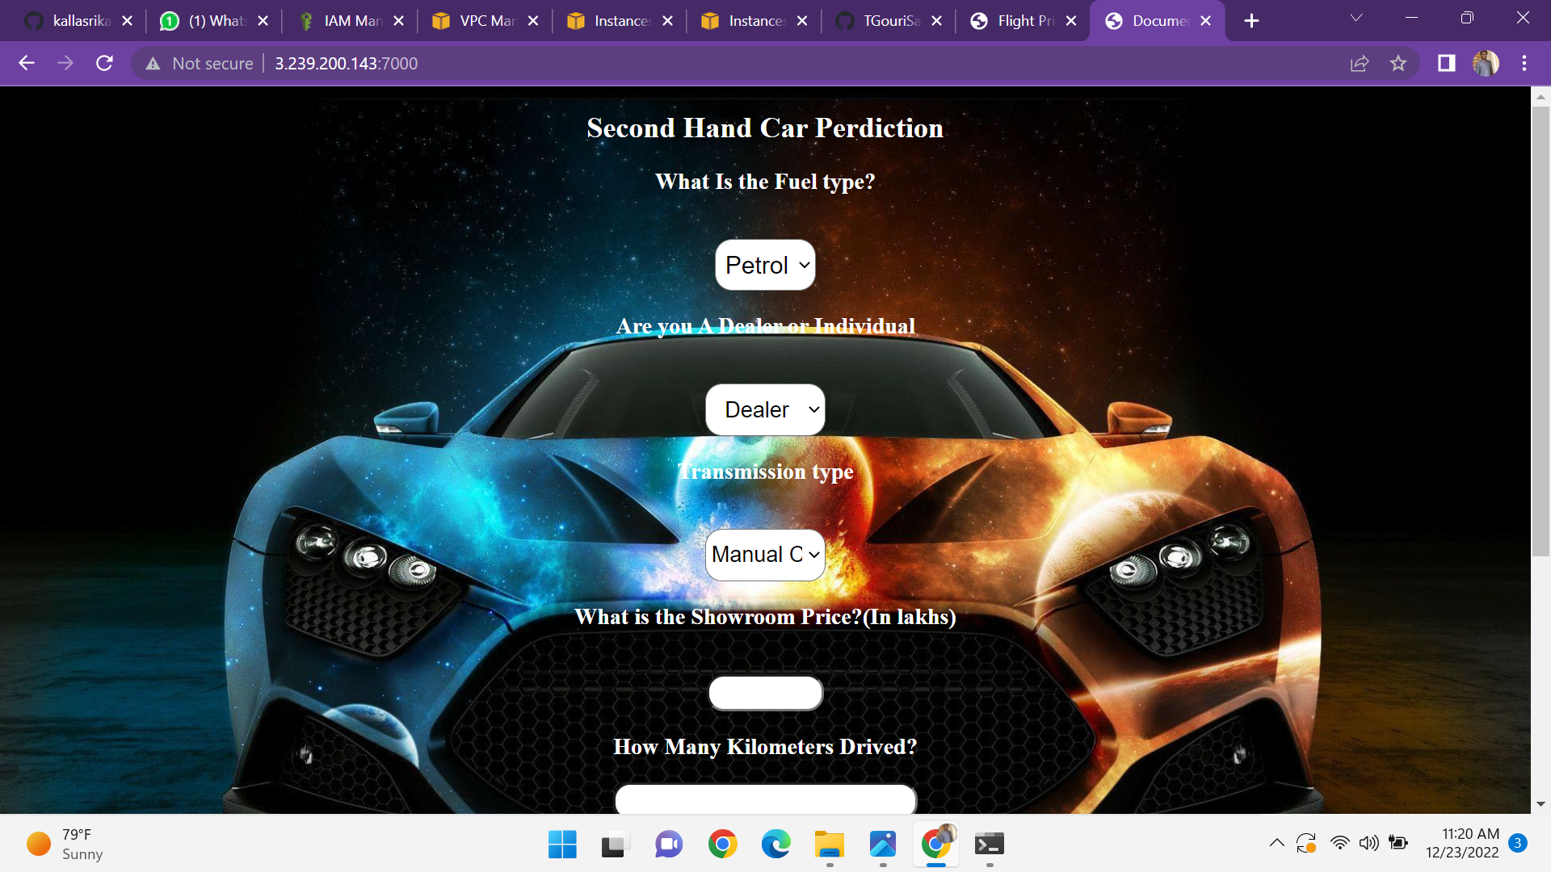

And after clone the repo and same edit app.py and copy the public ip on browser

